

A Report

On

**“WEB DEVELOPMENT”**

Batch Details

S Sourabha

20211CIT0145

8CIT-01

**School of Computer Science,**

**Presidency University, Bengaluru.**

Under the guidance of,

Dr. Sharmasth Vali Y

School of Computer Science,

Presidency University, Bengaluru

**CONTENTS**

1. Introduction about Internship
2. Literature Review
3. Objectives

## Methodology

1. Timeline for Execution of Project
2. Expected Outcomes
3. Conclusion
4. References

**1. INTRODUCTION**

The Human Resource Management System (HRMS) is an enterprise software solution designed to automate and streamline HR processes within an organization. Traditionally, HR departments rely on paper-based documentation and manual approvals, which can lead to inefficiencies, delays, and errors. The HRMS digitizes these processes, making them more efficient, transparent, and user-friendly.

* 1. **Purpose of the HRMS System**

The main goal of HRMS is to enhance workforce management by integrating:

* **Recruitment & Onboarding** – Digital offer letters & employee login creation.
* **Attendance Management** – Real-time attendance tracking & reporting.
* **Leave Management** – Employees can request leave, and managers can approve/reject it through a systemized workflow.
* **Off boarding Process** – Proper exit management, ensuring compliance and data security.
* **Employee Engagement** – Private social media for internal communication and team collaboration.

By implementing HRMS, companies can save time, reduce paperwork, minimize errors, and improve overall efficiency.

**2. LITERATURE REVIEW**

The literature review discusses existing HRMS systems, their limitations, and how the proposed system overcomes these challenges.

**2.2. Challenges in Existing HRMS Systems:**

* **Lack of Integration**: Recruitment, onboarding, and employee management are often handled separately, making data synchronization difficult.
* **Manual Processes**: Offer letter generation, attendance tracking, and leave approval are often still paper-based or require excessive human intervention.
* **Limited Employee Engagement**: Many HRMS systems do not include a social media feature, limiting internal communication.

**2.3. How the Proposed HRMS Addresses These Issues:**

* **A Fully Integrated Solution**: Combines recruitment, onboarding, attendance, leave management, and off boarding into a single platform.
* **Automation of Manual Tasks**: Uses digital workflows for offer letter generation, attendance tracking, and leave approvals.
* **Enhanced Employee Interaction**: Incorporates a private social media module to facilitate collaboration.

1. **OBJECTIVES**

**3.1. Key Goals of the HRMS System**

**Automate Recruitment & Onboarding**

* Replace traditional offer letters with digital login credentials for new hires.
* Seamless integration of new employees into the company’s ecosystem.

**Centralized Attendance & Leave Management**

* Real-time tracking of employee attendance through biometric or web-based login.
* Streamlined leave request and approval process with hierarchical permissions.

**Private Social Media Platform**

* Encourages collaboration by allowing employees to post updates, share ideas, and communicate.

**Secure Off boarding Module**

* Ensures proper data handling, access removal, and compliance when employees leave.

**User-Friendly Interface**

* Designed for HR personnel, managers, and employees to use easily.

**EXPERIMENTAL DETAILS/METHDOLOGY**

**4. METHODOLOGY**

**- DESIGN PROCEDURE**

**Technologies Used**

|  |  |
| --- | --- |
| Component | Technology Used |
| Frontend | React.js |
| Backend | Node.js |
| Database | MongoDB / PostgreSQL |
| Security | CAPTCHA, JWT Authentication |
| Hosting | AWS, Firebase |

**System Architecture**

The system follows a modular development approach:

* **Recruitment & Onboarding Module**
* Automates offer letter generation.
* Provides login credentials to new employees.
* **Attendance & Leave Management**
* Uses a digital attendance system (Biometric/Web Login).
* Employees can apply for leave via the system, and managers approve/reject requests.
* **Social Media Platform**
* Employees can post, comment, and share updates internally.
* Ensures a closed and secure communication environment.
* **Off boarding Module**
* Ensures data security and compliance when an employee exits.
* **Security Features**
* CAPTCHA for authentication to prevent bot attacks.
* Role-based access control to manage different user permissions

1. **EXPECTED OUTCOMES**

By implementing this HRMS, the organization will achieve:

* **A fully automated HRMS system** – Eliminates manual HR tasks.
* **User-friendly interface** – Easy navigation for employees & HR.
* **Real-time attendance tracking & leave approval** – Ensures accuracy and efficiency.
* **Private social media module** – Encourages employee collaboration.
* **Secure data handling** – Ensures proper management of employee data.

1. **TIMELINE OF THE PROJECT/ PROJECT EXECUTION PLAN**

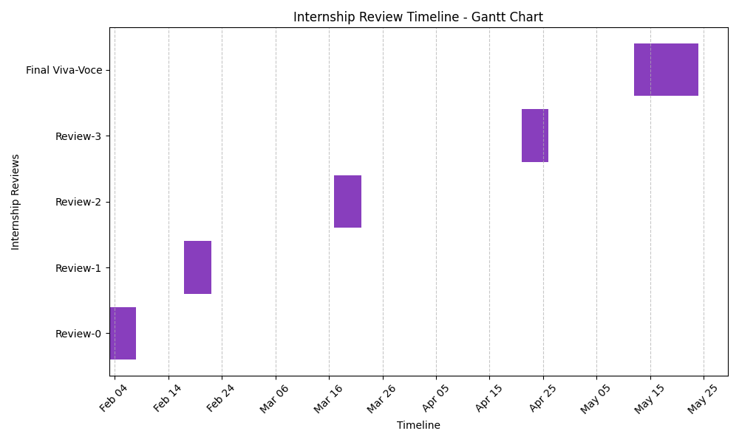

1. **CONCLUSION**

The HRMS system provides a modern, digital solution for handling HR processes. By integrating recruitment, onboarding, attendance, leave tracking, and social interactions, it enhances efficiency and transparency. Organizations adopting this system can expect better workforce management, increased employee engagement, and streamlined HR processes.

**REFERENCES**

React.js Documentation: https://reactjs.org/

Node.js Documentation: https://nodejs.org/

CAPTCHA Implementation Guide: https://developers.google.com/recaptcha/

HRMS Best Practices: https://www.researchgate.net/publication/123456789